# Components selection doc

28 NOV 2023 Dennis Yaskevich

This document provides background on some components selection for the project to be available for future reference and understanding of decision making.

Headings in this documents are numbered by the Electrical block diagram numbers.   
The latest version of the Block diagram should be available under the following path:  
<repository root>\Electronics\2_Block-diagram

## General guidelines

When selecting components for this project the following guidelines have to be followed:

1. Use hand-solder friendly packages
   1. use 0603 SMD packages for passive components
2. Select components that require software based on libraries availability to avoid writing them
3. Select components for Analog section not looking at the cost (it will be optimized later)
4. When possible use “jelly beans parts” => pick general components (like power supplies) that support multiple manufacturers parts on the same footprint.
5. Components should be available in LSCS stock and be suitable for JLCPCB SMT serivce

## Block P6. Selecting 5V LDO

#### Requirements for 5V LDO:

1. Expected values of current to be sinked from the LDO is 147mA based on  
   <repository root>\Electronics\3_Calculations&Simulations\Power Table.xlsx
2. Fixed 5.0V output voltage 1% precision
3. Maximum input voltage should be above 10V (supplied from x2 4.2V li-ion batteries)
4. 5V LDO must have EN pin to be able to turn off all downstream devices with single GPIO
5. Low quiescent current is desired feature to not drain the battery as much when disabled.
6. Relative modern IC is desired to have improved PSSR speak and control loop stability

Component used in Hardware rev2 HT7550-1 is rejected because of missing EN pin. -> ~~SOT-89, SOT23-3~~

Based on guideline 4 industry standard package must be selected.  
Based on requirement 1, it would be good to pick LDO with at least 300mA maximum output current. 500mA is best. -> ~~SOT23-5~~

#### Investigation of LDOs available in SOIC8 & HVSOP8 packages

TI selector search filter: [https://www.ti.com](https://www.ti.com/power-management/linear-regulators-ldo/products.html#1154=5%3B5&2192=Enable&2954=HVSSOP%3BSOIC%3BHSOIC&2955=8&238max=10%3B100&451max=0.3%3B7.5&)

Onsemi selector search filter: [https://www.onsemi.com](https://www.onsemi.com/products/power-management/linear-regulators-ldo#products=fi0xMX52YWx1ZX4zfk1pY3JvOH5TT0lDLTh+U09JQy04IEVQfnN0YXR1c352YWx1ZX4zfiF+TGFzdCBTaGlwbWVudHN+IX5MaWZldGltZX4hfk9ic29sZXRlfjcwNzgzfnZhbHVlfjF+WWVzfjI1MDIzNjJ+cmFuZ2V+Mn4wLjN+MC41fg==)

Diodes search filter: [https://www.diodes.com/](https://www.diodes.com/products/power-management/linear-and-low-dropout-ldo-regulators/#collection-9699=~(Packages~(~'MSOP-8EP~'SO-8~'SO-8EP)~VIN*20*28Max*29*20*28V*29~(~8~100)))

LCSC search filter: [https://www.lcsc.com](https://www.lcsc.com/products/Linear-Voltage-Regulators-LDO_387.html) (see as per 29 Nov P6_5VLDO_selection_www.lcsc.com.jpeg)

|  |  |  |  |
| --- | --- | --- | --- |
| Pinout | Available MPNs (datasheet) | Key specs | Comment |
|  | [tps7b82-q1](https://www.ti.com/lit/ds/symlink/tps7b82-q1.pdf?ts=1701173973833&ref_url=https%253A%252F%252Fwww.ti.com%252Fproduct%252FTPS7B82-Q1%252Fpart-details%252FTPS7B8250QDGNRQ1) |  | Not available LCSC |
| [AP7583Q_AQ](https://www.diodes.com/assets/Datasheets/AP7583Q_AQ.pdf) |  | Not available LCSC |
|  | [MIC49150](https://ww1.microchip.com/downloads/en/DeviceDoc/mic49150.pdf)  [MIC5219](https://ww1.microchip.com/downloads/en/DeviceDoc/MIC5219-500mA-Peak-Output-LDO-Regulator-DS20006021A.pdf)  [MIC39101](https://datasheet.lcsc.com/lcsc/2304140030_Microchip-Tech-MIC39101-5-0YM_C148027.pdf) | Other options from Microchip, just for reference | Not available LCSC |
| [MIC5209](https://ww1.microchip.com/downloads/en/DeviceDoc/20005720A.pdf) | 1% at 25,  Fixed output V | 144 pcs stock, 1.37$ |
| [spx3819](https://assets.maxlinear.com/web/documents/spx3819.pdf) | 1% at 25,  Fixed output V | No stock |
| [TL5209DR](https://datasheet.lcsc.com/lcsc/2001050532_Texas-Instruments-TL5209DR_C478073.pdf) | 1% | EOL part in stock just for reference |
| [AP2213](https://www.diodes.com/assets/Datasheets/AP2213.pdf) | Only available in 3V3 output V |  |
|  | [TLV767](https://www.ti.com/lit/ds/symlink/tlv767.pdf?ts=1701182486065) |  | No stock |
| [KFXX](https://datasheet.lcsc.com/lcsc/2304140030_STMicroelectronics-KF50BD-TR_C222151.pdf) | 2% tolerance |  |
| [ADP7104](https://datasheet.lcsc.com/lcsc/2304140030_Analog-Devices-ADP7104ARDZ-5-0-R7_C132278.pdf) |  | High cost |
| [L4931CD50](https://www.lcsc.com/product-detail/Linear-Voltage-Regulators-LDO_STMicroelectronics-L4931CD50-TR_C283394.html) | 2% tolerance |  |
|  | [TPS767](https://www.ti.com/lit/ds/symlink/tps767.pdf?ts=1701210948468&ref_url=https%253A%252F%252Fwww.ti.com%252Fpower-management%252Flinear-regulators-ldo%252Fproducts.html) | 2% tolerance | No stock |
| [NCP3334](https://www.onsemi.com/download/data-sheet/pdf/ncp3334-d.pdf) | **0.9% tol**, **only adjustible is available** | 1773 stock 0.8$ |
| [TPS7350QDR](https://datasheet.lcsc.com/lcsc/2304140030_Texas-Instruments-TPS7350QDR_C12102.pdf) | 2% tolerance | 263 in stock 3$ |
|  |  |  |  |

**MIC5209-5.0YM-TR** has been selected ([lcsc](https://www.lcsc.com/product-detail/Linear-Voltage-Regulators-LDO_Microchip-Tech-MIC5209-5-0YM-TR_C71226.html)).

## Block P5. Selecting 5.3V LDO

#### Requirements for 5V LDO:

1. Expected values of current to be supplied is below 50mA, any package is fine
2. EN feature is required to be able to disable negative supply

This part is very generic and easy to pick.

Diodes search filter: [https://www.diodes.com/](https://www.diodes.com/products/power-management/linear-and-low-dropout-ldo-regulators/#collection-9699=~(VIN*20*28Max*29*20*28V*29~(~8~100)~Packages~(~'SOT25~'SOT25*20*28Type*20A1*29)))

LCSC search filter: [www.lcsc.com](https://www.lcsc.com/products/Linear-Voltage-Regulators-LDO_387.html)

|  |  |  |  |
| --- | --- | --- | --- |
| Pinout | Available MPNs (datasheet) | Key specs | Comment |
|  | [AP2202](https://datasheet.lcsc.com/lcsc/2004082232_Diodes-Incorporated-AP2202K-ADJTRG1_C507873.pdf) | 1%, 150mA, En | 0.14$ 3k in stock |
| [AP2210](https://www.diodes.com/assets/Datasheets/AP2210.pdf) | 1%, 300mA, En | 0.12$ 2k in stock |
| [SPX3819M5](https://datasheet.lcsc.com/lcsc/1806151814_MaxLinear-SPX3819M5-L-TR_C9056.pdf) | 1%, 500mA, En | In stock |
| [TPS76301DBVR](https://datasheet.lcsc.com/lcsc/1809151115_Texas-Instruments-TPS76301DBVR_C7727.pdf) | 1%, 150mA, En | In stock |

AP2210 is selected.

## Block P7. Selecting the load resistor for negative voltage gen

According to testing documented in the bring up report, the negative voltage generator features some additional noise caused by Pulse skipping mode that is enabled at light load.

Changing the component is too big of a change for the minor revision and it’s not target of MVP. Quick workaround is adding 220 Ohm resistor as “dummy load” to consume additional current and avoid enabling the light load mode.

*V*OUT = -5 *V*

*R* = 220 *Ω*

*P* = *V*OUT2*R* = (-5 *V*)2220 *Ω* = 0.114 *W*

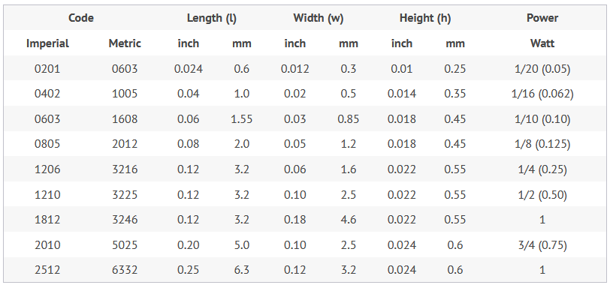

It would be safe to have at least 2 times power rating compared to the calculated power.

I would go with 1206 resistor

## Block P1. Batteries charger

Tp4056 is proven low cost solution for battery charging for single cell. It’s commonly used as IC and as breakout PCB. In this design 2 batteries connected in series must be charged. The first idea is to check the 2 cell version of TP4056:  
- TP5100 the battery charger IC for 2 cells in series from this same manufacturer

Problems:

* TP5100 does not support dual sourcing.
* it does not have the hand soldering friendly package.

Alternative circuit for P1 block is the battery charger based on [LM317 LDO](https://www.ti.com/lit/ds/symlink/lm317.pdf). This is dual sourcable jelly bean part that supports batteries charging. But in default configuration it does not support CC CV battery charging

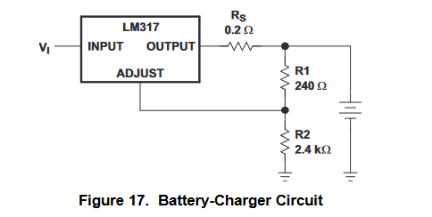

There is another configuration that is supposed to handle it, but it require careful simulation and test

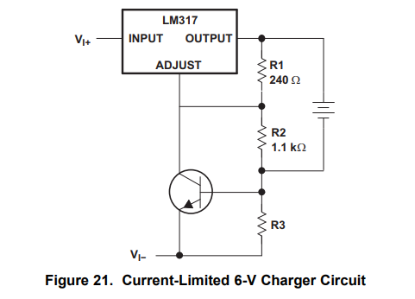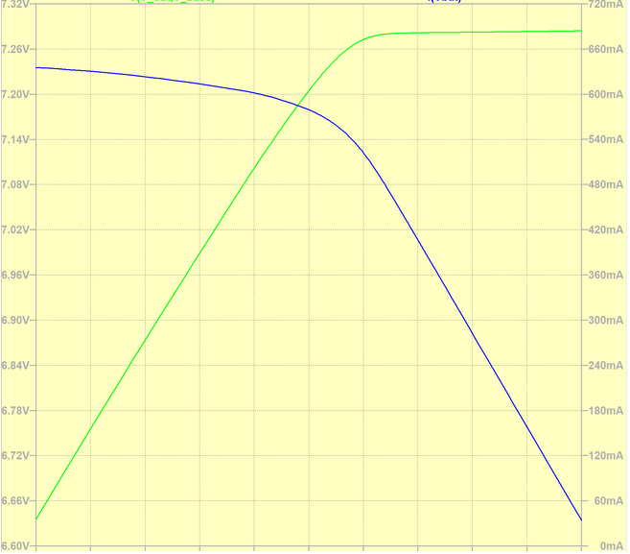

<https://electronics.stackexchange.com/questions/503642/lithium-ion-battery-charger-using-lm317>

For now I’m skipping the LM317 and keep TP5100 in the design. This IC must be replaced in the subsequent releases of the Flexi-Teer by some linear battery charging solution but for now it stays on SCH simply as something that works.

Schematic is implemented according to the ref. design from the datasheet. But unfortunatley tehre are a few different datasheets out there with different typical application circuits:

* [<repo root>/Electronics/1_Datasheets/Charger_TP5100.pdf](http://toppwr.com/uploadfile/file/20230304/6402f53e7e8d9.pdf)

Reference schematic from official datasheet

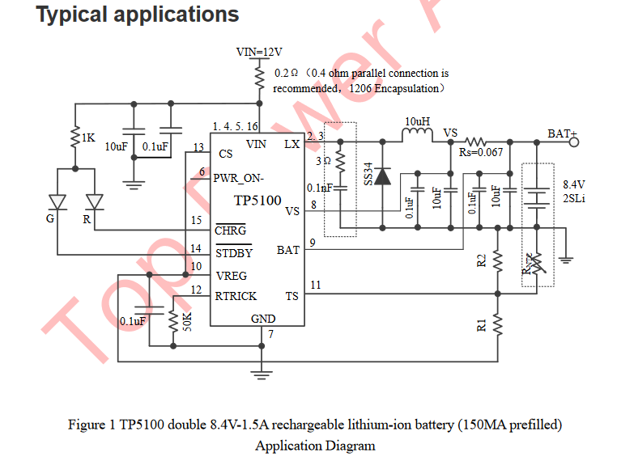

TS Pin to battery NTC (Negative temperature coefficient thermistor) sensor

In case TS Less than the voltage at pin VREG of 45% or greater than VREG Voltage 80% It means that the battery temperature is too low or too high, the charging is suspended. in case TS Direct access GND Battery temperature detection function is canceled, the charging function properly.

Alternative implementation of the temperature sense feature.

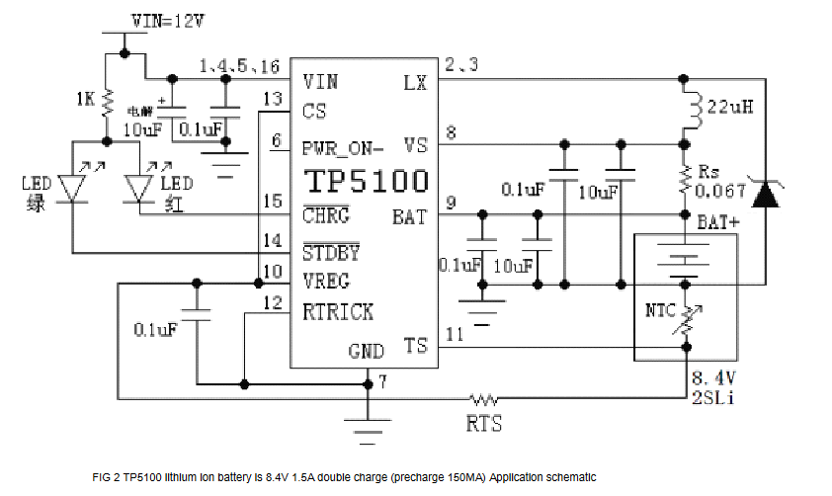

This schematic illustrates how to implement “Power Path” feature

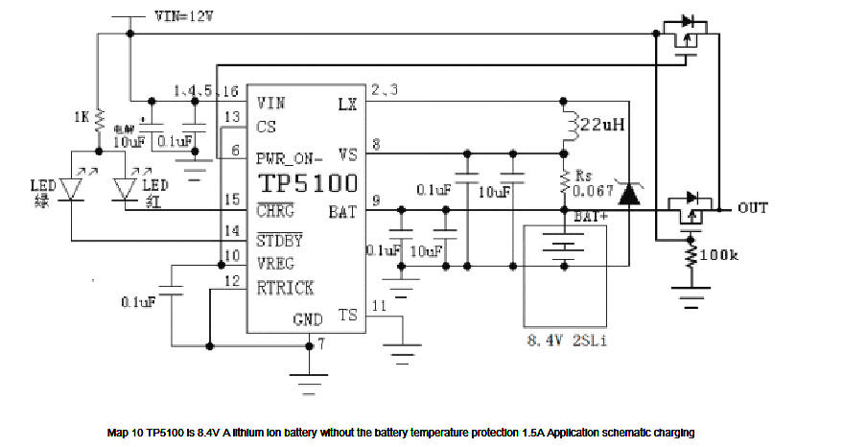

In the datasheet I found when working on rev.2.0 of FlexiTeer 10V were specified as maximum VIN.

Now in all datasheets I can see 12V input voltage but I would still keep 9V power supply as we already bought it. +I already tested this IC with 9V power supply.   
Yes, it produces audible noise and it would be nice to check if it’s still the case with 12V iput

Also it would be nice to check if adding 0.2 Ohm before the charger changes anything.

PWR_ON and CS pins also must be checked. Check how PWR_ON works when CS is 0

Measure VREG. Make sure CS works from 3V3